18.11.2021 Учебная группа 2ТО, 3-я пара

Преподаватель Иванова Наталия Викторовна
ОГСЭ.03 Иностранный язык (английский)

Тема: Достопримечательности Лондона.
Цель занятия:
образовательная: активизация лексики по теме «Достопримечательности Лондона», расширение словарного запаса студентов актуализация знаний по страноведению;
развивающая: развитие способности логически правильно и грамотно излагать свои мысли по теме; развитие способности анализировать предъявленный материал, выражать свое мнение по предложенной теме; развитие творческих способностей и эстетического вкуса.
воспитательная: развитие интереса к изучению иностранного языка; расширение кругозора: знакомство с достопримечательностями столицы Великобритании; приобщение к культурному и историческому наследию народа страны изучаемого языка.
Задачи занятия: увеличение объема знаний страноведческого характера в рамках предъявленной темы.
Мотивация: The topic “London. Places of Interest” is very actual for development of your communicative skills. Learning the topic will help you to acquire a good command of the spoken language. You’ ll be able to speak in dialogue, to present the capital of Great Britain.
Задание студентам:
- Выписать новые слова в тетрадь и выучить их.
- Прочитать текст. Понять основной смысл прочитанного. Выписать основные фразы из текста.
- Посмотреть фильм «Интересные места Лондона» https://youtu.be/Cp4SwAUBZfI.
- Выполнить упражнения 1-5, пройти тест.
Фотографию с выполненным заданием прислать на электронный адрес atata17@yandex.ru в срок до 08.00 19.11.2021 г.

План:
- Аудирование. Страноведческий материал достопримечательностям Лондона.
- Чтение и перевод.
- Работа с заданиями.
Литература:
- Буренина JI.C. Учебник английского языка. - М.: Высшая школа, 1978. - 127 экз.
- Парахина А.С. Учебник английского языка. - М.: Высшая школа, 1987. - 55 экз.
Глоссарий:

a capital-столица
population- население
to inhabit- населять
industry- промышленность
a suburb- пригород
to extend- расширять
to visit- посещать
entertainment- развлечение
a double-decker bus- двухэтажный автобус
sightseeings-достопримечательности
Buckingham palace-Букингемский дворец
Trafalgar square-Трафальгарская площадь
National gallery-Национальная Галерея
St. Paul's cathedral-Собор святого Павла
Tower of London-Тауэр Лондона
Parliament-Парламент
Big Ben-Биг Бен
London zoo-Лондонский зоопарк

Прочитать текст, переписать основные фразы в тетрадь.

Parts of London
London is traditionally divided into several parts: The City of London, which is the financial center of the United Kingdom, the West End, which is the area of museums, art galleries, largest department stores, cinemas, and hotels. West End and is associated with wealth and luxury; and the East End, which is the industrial part of London and is very important for the commerce.
The sightseeings of London
The Tower of London
Most of London sights, such as the Tower, the Houses of Parliament, Westminster Аbbеу, Trafalgar Square, and others are famous all over the world. The Tower of London was founded in the 11th century by William the Conqueror. The Tower in the past was а fortress, а palace, and а prison. Though the kings were born, lived and were married there, it happened also that kings and queens were murdered in the Tower. It was said that whoever held the keys to the Tower, held the keys to the kingdom. The Tower has several towers: The Jewel Tower, where the Royal precious jewels are kept, the White Tower, in which the Kings of England held their Court, and others. One of the towers is called the Bloody Tower, where the king Edward V and his brother were murdered. The Duke of York. Queen Anne Boleyn, the Princess (afterwards Queen) Elisabeth and many other people were in prison in the Tower. Now the Tower is а museum and the Crown jewels and other treasures are kept there. The Guard, known as ''beefeaters" still keep watch. The Ceremony of the Keys that is centuries old takes place every night. Now the only inhabitants of the Tower are ravens. There is а legend that the Tower will fall if it loses its ravens. Therefore, the bird s with clipped wings are carefully guarded.
The Houses of Parliament
The Houses of Parliament are the most beautiful buildings not only in London, but in the whole Europe. The Houses of Parliament are also called the Palace of Westminster. The Queen enters the Palace of Westminster only on the day of the opening of Parliament at the beginning of the session. She wears а crown and many jewels when she makes her speech from the Throne in the House of Lords. А fire destroyed the old Houses of Parliament. The new Houses of Parliament were built in 1857. The famous 320 foot (97.5 meters) clock Tower is called "Вig Ben" after Sir Benjamin Hall under whose direction the construction of the clock was conducted.
St. Paul's Cathedral
St. Paul's Cathedral It took the architect Christopher Wren 35 years to build the Cathedral. It is one of the most beautiful pieces of architecture in Europe. It has а huge dome with а golden ball on the top. The interior of the Cathedral is very beautiful too.
The British Museum
There are many museums and art galleries in London. The British Museum is famous for its rich library (about 7 000 000 books). It is also the Museum of History, Archaeology, Art and Ethnography. The British Museum contains the most important collections in Britain.
The Buckingham Palace
The Buckingham Palace is the place where the Queen of England lives.
Trafalgar Square
Trafalgar Square is the geographical center of London. It was named in the memory of Admiral Nelson's victory in the battle of Trafalgar in 1805. The tall Nelson's Column stands in the middle of the square. Opposite the Nelson monument is the National Gallery and the National Portrait Gallery. They contain the finest art collections of the world.
Westminster Аbbеу
Westminster Аbbеу is the place where the coronation of nearly all kings and queens has 1 taken place since the time of Conquest. Many of them are buried here as well as some other famous people of the country. Westminster Abbey is famous for its architecture and history. There are the graves of some of the world's famous writers, poets and scientists: Chaucer, Charles Dickens, Tennyson, Thomas Hardy, Kipling and others are buried here. There in the Poet's Comer there are memorials to Shakespeare and Milton, Burns, Byron, Scott, Thackeray and Longfellow. Here is also the grave of the Unknown Soldier who was killed in the First World War.
Parks in London
There are many parks in London: Hyde Park with its Speaker's Corner, St. James Park, Green Park, and Kensington Park. Regent’s Park was originally a royal hunting forest. Now it is the home of London Zoo. Also there are lots of other parks, gardens, playground in the city.
Задание 1 Закончить предложение
- The United Kingdom of Great Britain and Northern Ireland is situated ………
- Great Britain consists of four parts: ....................................................................
- The capital of the United Kingdom is................................................................
- The most important rivers in the United Kingdom are......................................
- The most famous educational centers are...........................................................
- The United Kingdom is a monarchy and the Queen is.......................................
- The British Parliament consists of two chambers:...............................................
Задание 2 Контрольный тест.
1. _______ is an industrial part of London.
A. The West End
B. The East End
C. The City
2. Big Ben is connected with the _______
A. building of Parliament
B. building of the Tower
C. building of Westminster Abbey
3. There is Speaker’s Corner in _______
A. St. James park
B. Kensington park
C. Hyde park
4. The residence of the Prime-Minister is _______
A. White Hall, 2
B. Downing Street, 10
C. Piccadilly, 15
5. _______ in the past was a fortress, a palace a prison
A. The Tower of London
B. St. Paul’s Cathedral
C. Westminster abbey
6. The Queen lives in the _______
A. Kensington palace
B. Westminster abbey
C. Buckingham palace
7. Any tourist can see the tall Nelson’s column and the national gallery, visiting the _______
A. Soho
B. Trafalgar Square
C. Hyde park
8. You can visit _______ to see its rich library and the museum of History Art Archeology and Ethnography
A. The building of parliament
B. The British museum
C. The Buckingham palace
9. The world’s famous English writers, poets, scientists were buried in _______
A. Westminster Abbey
B. St. Paul’s Cathedral
C. The Tower of London
10. All the main banks and offices are situated in _______
A. The West End
B. The East End
C. The City
11. London is the capital of the UK It stands on both banks of the _______
A. Severn
B. Senna
C. Thames
12. More than _______ millions people live in London
A. 7
B. 5
C. 9
13. _______ is the street, where the newspaper are produced in London
A. Green Street
B. Fleet Street
C. Dawning Street
14. What type of transport is very popular for sightseeing in London? _______
A. A tram
B. A ship
C. A double-decker bus
Задание 3 Дополнить диалог:
-Have you ever been to London?
-No, it’s my first visit here.
- Have you seen much of the city?
- No, I haven’t. Can you tell me what are the most interesting places to visit?
-Willingly. I’d advise you to see ….
- Is it far from here?
-No, most of places of interest are situated in the very centre of London.
- What else would you advise me to visit?
-You’d better start with…
- Thank you ever so much. You’ve given me so much information.
Задание 4 Закончить диалог:
A.- Excuse me. I am a stranger in London. Is it Possible to see anything of London in a day or two?
B. …
A. –What do you think I ought to see first?
B. …
A.- How long will it take me to get there?
B….
A. - Thank you very much.

Задание 5 Переведите на английский
Коммерческий центр, главный порт, был основан, стал очень богатым, эпидемия чумы, разделен, сердце Лондона, мало людей, старинные здания, содержит, официальная резиденция королевы.
Задание 6 . Your friend, who has never been to London, wants to learn more about it. Answer his/her questions.
1. What is the population of London?
2. Who founded London?
3. What was the first name of London?
4. What catastrophes occurred in the 17th century?
5. What parts is London divided into?
6. Where is St.Paul’s Cathedral situated?
7. What is the official residence of the Queen?
8. What sights of interest is London famous for?
9. What is the oldest royal residence in London?
Задание 7. Finish the sentence…
1. London is the main port of …
2. It was founded by …
3. The Great Fire destroyed …
4. London is divided into …
5. There are a lot of … in the City.
Задание 8. Ask questions to the given answers.
1. 9 million people
2. Londinium
3. in the 16th century
4. the seat of Government
5. Buckingham Palace
Задание 9. Аnswer the given questions.
Посмотреть фильм «Топ 10 достопримечательностей Лондона»
https://www.youtube.com/watch?v=RKNBIitoXMQ
St.Paul’s Cathedral
      - What is the cathedral famous for?
      - Who built it?
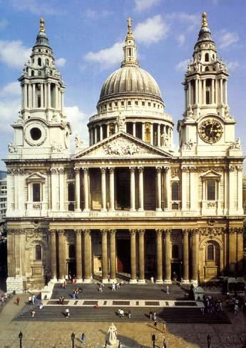 | It is one of the symbols of London. It was built in 1710 by a great English architect Christopher Wren. This cathedral is famous for the Whispering Gallery: if you whisper anything on one side of the gallery, your words will be heard very clearly on the other side.  Every year a special ceremony is held on the occasion of the Monarch’s birthday.
Westminster Palace (Big Ben)
- When was it constructed?
- Which tower is the most famous? Why?
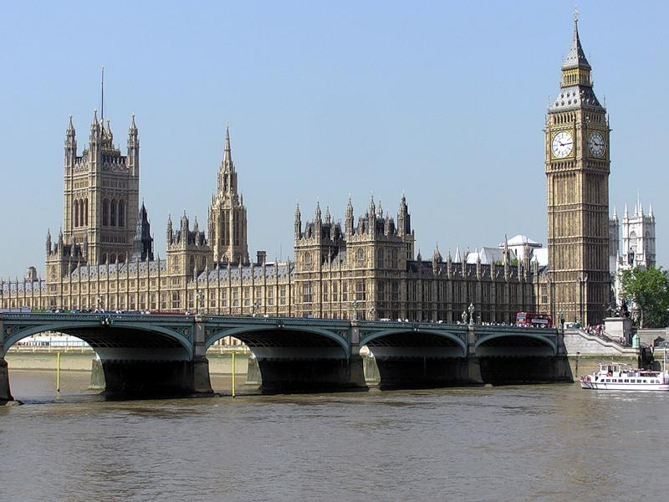 | Westminster Palace is the seat of British Parliament. Another name is the Houses of Parliament. It was constructed in the 11th century. It contains 1,100 rooms, 100 staircases and 11 halls. It has got 3 massive towers: the Victoria Tower, the Middle Tower and St.Stephen’s Tower. The last Tower is the most famous, because it houses the clock called Big Ben.  The Houses of Parliament consist of the House of lords and the House of Commons.
Westminster Abbey
- Who was the first monarch crowned there?
- Who is buried there?
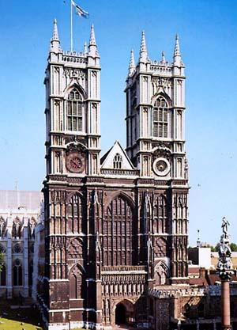 | It’s the oldest and the most important church in England, the official church of the British Monarch. The coronations take place there and many kings and queens are buried there. The first Monarch who was crowned there was William the Conqueror in 1066. (Вильгельм Завоеватель)  Here there is the Poet’s Corner where there are monuments to some great British writes: William Shakespeare, Robert Burns, Jane Austen and others.
The Tower of London
- Who founded the Tower of London?
- What can we see there now?
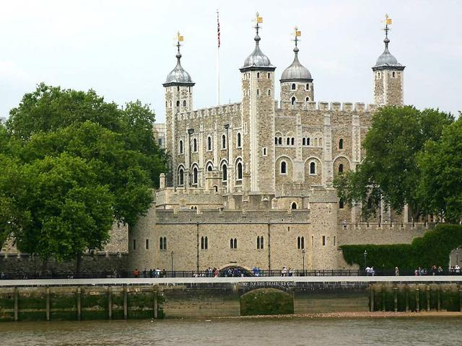 | Today its official title is “Her Majesty’s Palace and fortress of the Tower of London”. It was founded by William the Conqueror in 1078 as a fortress. Later it was the Royal residence, the Royal Observatory, a prison, a zoo. Now it is a museum, which contains the national collection of armour and the Crown Jewels.
Trafalgar Square
- What can we see in the centre of Trafalgar Square?
- What do the lions symbolize?
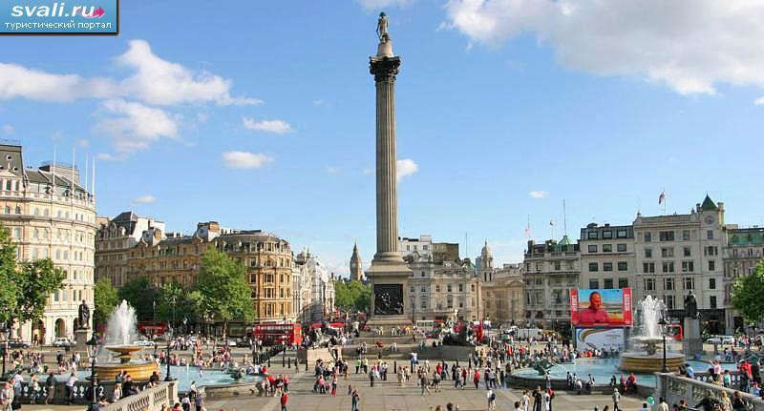 | This is the largest square in the central London. In the centre of it there is Nelson’s Column. It was created in the memory of the victory of Admiral Nelson over Spain in 1805 at Cape Trafalgar. The column is 50 metres high. Around the column there are 4 bronze lions. They symbolize courage.
Parks of London
- What is the oldest park in London?
- What can we see in Hyde Park?
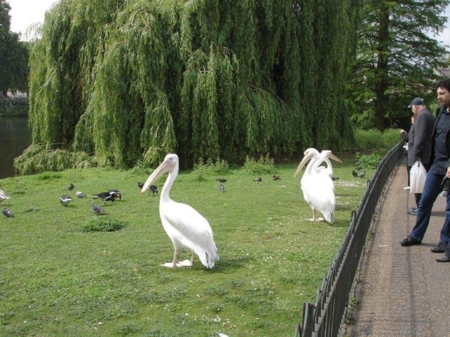 | London is a green city with lots of parks and gardens. The three best known parks are: Hyde Park, St.James’s Park, Kensington Gardens. The most popular attraction in Hyde Park is The Diana Memorial Fountain in the shape of a heart. St.James’s Park is the oldest park in London. It is famous for the Queen Victoria Memorial.
Buckingham Palace
- How many rooms are there?
- When is this Palace open for visitors?
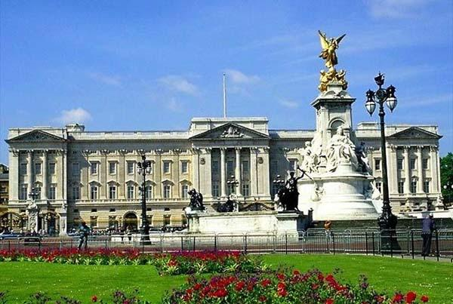 | It’s the official residence of the British Monarch. It contains 400 rooms, a swimming-pool, a tennis-court, and a large garden with a lake. This Palace is open for visitors during August and September when the Queen is on holiday.  In summer the Queen gives three garden parties which usually start at 4 pm. People who have done good work in different fields: scientists, politicians, sportsmen are invited there.
Задание 10. Which of these sights would you like to visit? Why? What do you know about it?
I would like to visit
to see with my own eyes
popular among tourists
I am interested in … (History, Architecture, Painting)
I want to see …

